Chamois Horn Length

**Introduction**

The chamois (*Rupicapra rupicapra*) is a small bovid species of “goat-antelope” native to the mountainous regions of southern Europe. Both males and females have short, hooked horns, which the slightly larger males use to spar with. For most of the year, females and kids live in small herds of 15-30 individuals and adult males live separately (Chamois, 2024). During the rut, which lasts from autumn to mid-winter and peaks in late November, males compete using their horns, sparring for access to unmated females. Pregnant chamois females typically carry only one kid at a time over a gestation period of approximately 170 days (Chamois, 2024). Kids are fully grown at 1 year but do not reach sexual maturity until 3-4 years of age and the average lifespan of wild chamois is about 15-17 years (Chamois, 2024). Chamois are herbivorous prey animals with many predators including humans, who hunt chamois for meat, furs, and chamois leather.

Hunting data was collected over 40 years (1977-2016), with data missing from years 1985, 1986, and 1989, totaling 4934 hunted chamois included in the data set. For each hunted individual, the date was recorded as well as the sex, age and cohort, body mass, population density at the kid’s birth, and the horn lengths of both the right and left horn. The goal of this analysis is to determine predictive factors of horn length and conclude if recent human hunting activity has impacted chamois morphology. We hypothesize that body mass and age will be the greatest predictors of horn length, where larger and older individuals would be predicted to have longer horns. Sex and population density at the time of birth we also expect to predict horn length, as males typically have longer horns than females, and high-density populations create higher competitive pressure for males to grow longer horns to better compete. We also hypothesize that higher hunting pressure should not have a direct effect on horn length, as chamois are not being directionally selected via hunting based on their horns but more likely on their mass. If mass is highly correlated with horn length, as we expect, high hunting pressure may reduce horn length, or if population density also predicts horn length, then lower population density may also reduce horn length.

**Methods**

The data was first explored to reveal correlated variables and trends over time. As both right and left horns were about equal for all individuals, the two horn lengths were combined into total horn length (hornT) to remove variability between horns. The total horn length was then used in all regressions and calculations. The hypothesized predictor variables (age, mass, sex, season, and density), were plotted against total horn length. As we expected age and mass to be highly correlated, they were also plotted against each other to determine the strength of correlation. The distribution of chamois data points (hunted individuals) by season was plotted as well as the distribution by month and grouped by sex to further uncover temporal relationships within the data set. The distribution of the data by sex and by density were also noted. Finally, density was plotted against season using a logistic regression.

Since sex and density data are binomially distributed, a poisson regression was used in initial generalized linear model using all hypothesized variables. The output of initial regression shows data are overdispersed so a negative binomial model was then used to test combinations of parameters and their individual effects on the explanatory potential of the model. The model improved with adding an interaction between age and mass, however the addition of month as a parameter did not substantially increase the R2 of the model, and therefore did not add much explanatory power, so it was excluded from the final model.

While the summary from the negative binomial glm showed high significance for all hypothesized variables, the estimates for both season and density were very small, and graphically, season and density showed high variation in total horn length, but not a strong trend. When season and density were tested as random effects, the AIC and pseudo R2 values improved for the model. Therefore, a mixed effect model with season and density as random effects, and age, mass, and sex as fixed effects was ultimately determined to be the final model with most explanatory power.

**Results**

The mean horn length in our data set was 364 ± 88 mm. Horn length was slightly higher for males (384 ± 87 mm) than females (338 ± 82 mm) but mean horn length did not significantly differ at high and low densities (356 ± 97 mm at high density, and 371 ± 76 mm at low density).

In our data set, almost 25% more males were hunted than females (2439 vs 1955 out of 4934). Most chamois were hunted in September and October, steeply declining by 61% in November and continuing to decline through February. However, the ratio of females to males increased during this later part of the season; whereas in September, 60% of chamois hunted were male, from December through February, the distribution is nearly 50-50 male to female. Vastly more 1 year olds hunted than any other age group (1100), 85% more than 4 year olds which were the next most represented age group (595). Since month was not included as a parameter in the final model, weight was not included for month, however future analysis could improve by adding weigh to sex and age.

Surprisingly, the dataset began hunting in exclusively low density populations and ended in exclusively high density populations, reaching 50% around 2002. Besides population density, no metric (horn length, age, or mass) significantly changed over time.

The formula of our determined model to predict horn length was:

hornT ~ age * mass + sex + (1 | season + density)

The parameter estimates confirmed that age, sex, and body mass were the strongest predictors of horn length (See Table 1), where βage = 46.56 ± 1.01 mm/year, βmass = 14.03 ± 0.24 mm/kg, βsex = 39.87 ± 1.67 mm (female to male). Body mass explained the greatest proportion of variance (35.4%), followed by age (26.2%), and sex (15.1%). The random effects of season and density also explained a sizable proportion of the variance (14.5% and 12.7%, respectively).

**Conclusion**

The greatest predictor of horn length was body mass, where horn length increased by 14.03 ± 0.24 mm/kg, explaining 35.4% of the variance in the model. Age was the second strongest predictor, which predicted an increase of 46.56 ± 1.01 mm/year and explained 26.2% of the model variance. Sex explained 15.1% of the variance, followed by season at 14.5% and density at 12.7%. As expected, age and mass were highly correlated and had an interaction that explained 11.3% of the variance. Our hypothesis that age and mass would be the strongest predictors is supported by the output of our model. Biologically, it is intuitive that as a chamois ages, both their horns and body mass will increase, and a larger animal is likely to have proportionally larger horns. It is also aligned with our hypothesis that males predict slightly larger horns than females, which is true of many horned bovids.

Contrary to our expectation and surprisingly, density did not have a substantial effect on horn length, though there was a stark shift in hunting of low density populations to high density populations from 1998-2012, reaching 50% around 2002. This could potentially be due to habitat fragmentation, pushing chamois into a smaller and more dense area, or could simply be due to changes in hunting tactics or regulations. Yields increased during the time of this shift between low and high density hunting populations, peaking between 2005-2009, which could potentially be explained by the wider variety of hunting strategies (at high and low density), abundance of chamois during those years, or increase in number of hunters reporting in the dataset.

Future analysis could improve by including location data to examine population density and habitat fragmentation, hunter ID and chamois total population estimates, to account for predator prey dynamics over longer time scales.

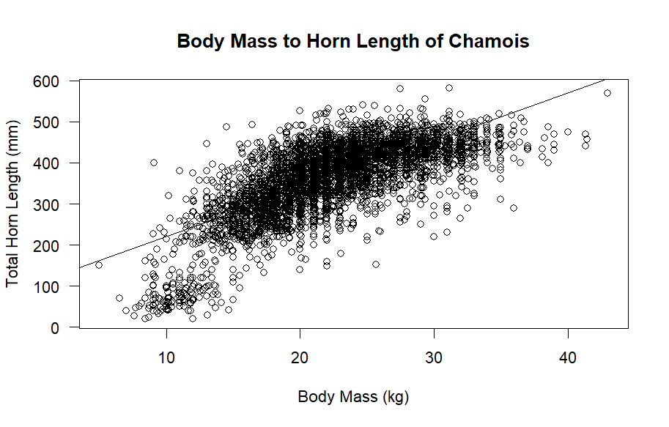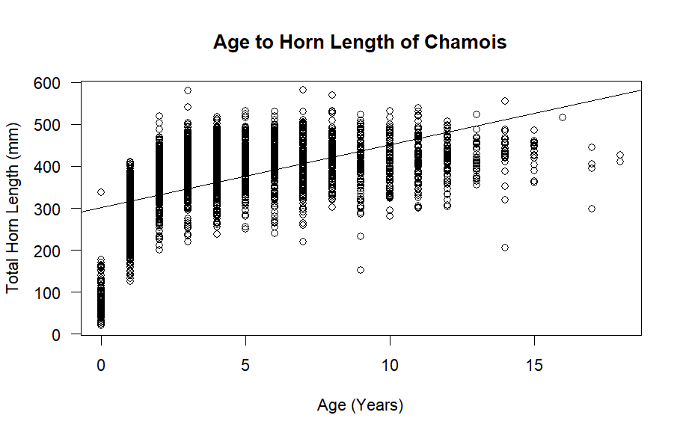Appendix

Figure 2: Horn length increases with mass β = 11.61 mm/kg

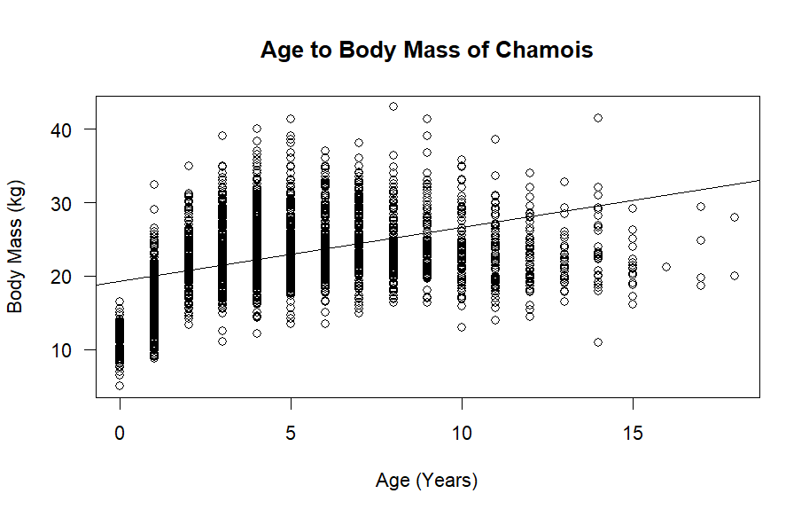

Figure 1: Horn length increases with age β = 14.98 mm/year

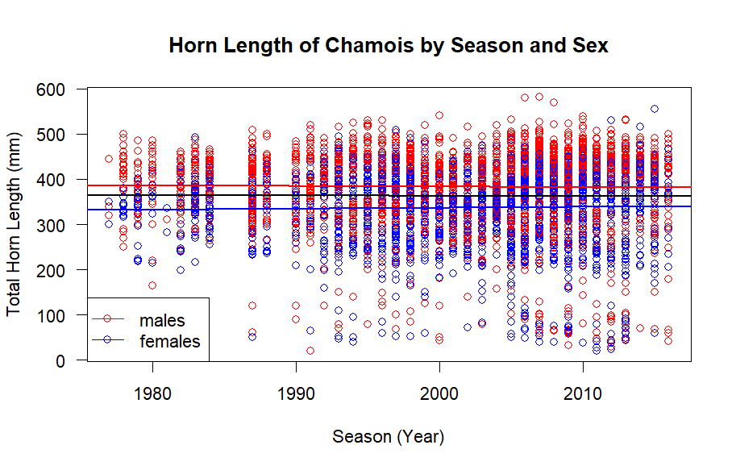

Figure 3: Mass increases with age β = 0.733 kg/year

Figure 4: Horn length is about constant over time for both sexes βMale = -0.101 mm/year, βFemale = 0.222 mm/year

ΒCombined = -0.098 mm/year,

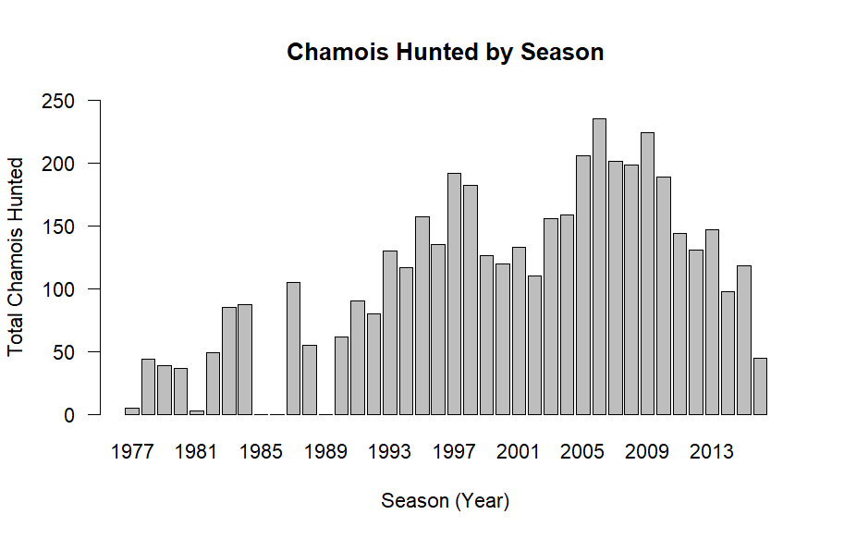

Figure 5: Hunting yields peaked 2005-2009 but were largely random, and three years lack data (1985, 1986, and 1989)

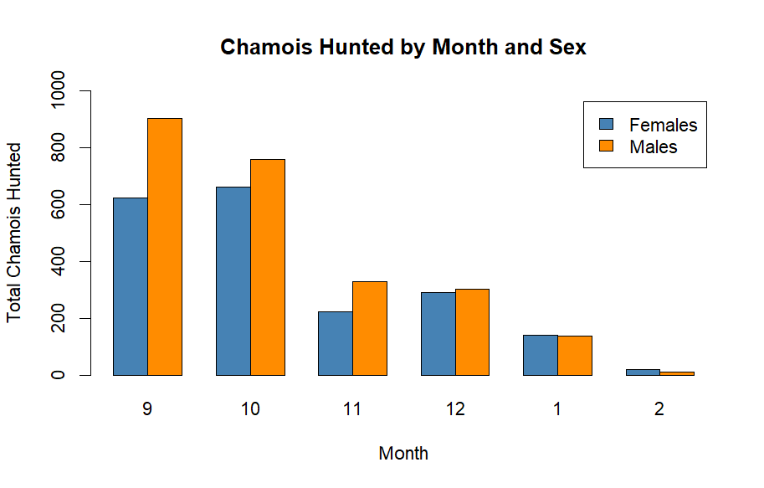

Figure 6: Hunting is highest in September and sharply declines between October and November but the ration of females to males increases in later months.

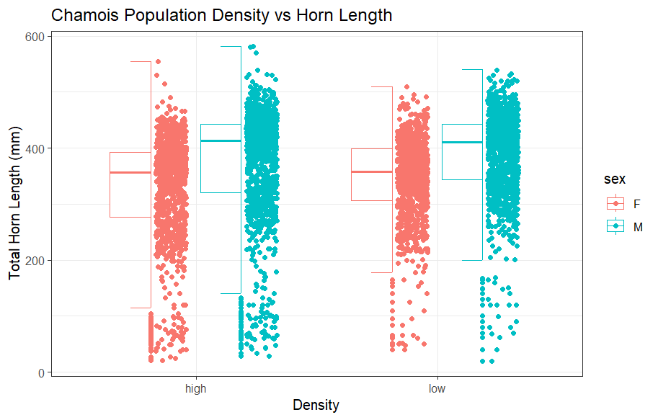

Figure 7: Horn length is nearly equivalent between high and low density populations

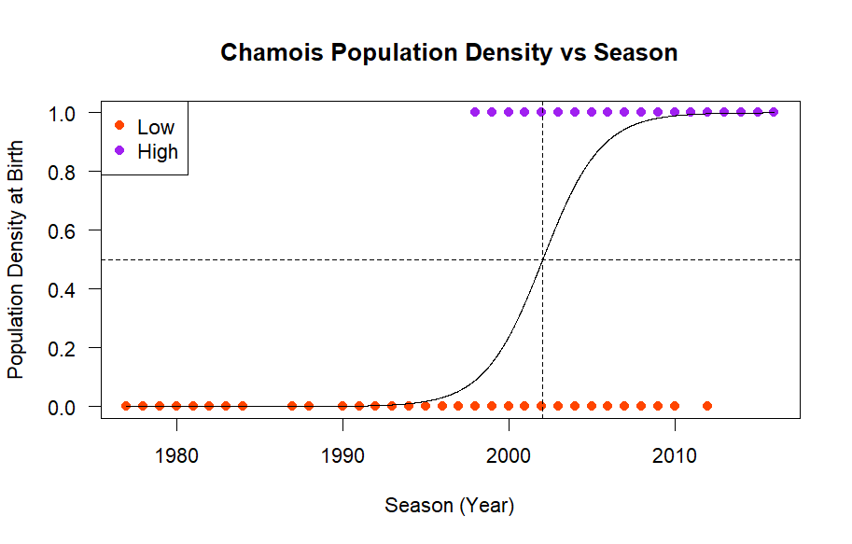

Figure 8: Hunting began exclusively in low density populations and ended in exclusively high density populations, increasing sharply between 1998 and 2012, reaching 50% in 2002.

|  |  |  |  |  |
| --- | --- | --- | --- | --- |
| **Mixed effect model summary** | | | |  |
| Formula: hornT ~ age * mass + sex + (1 | season + density) | | | |  |
| **Fixed effects** | **Estimate** | **Std. Error** | **R2 (M)** | **R2 (C)** |
| (Intercept) | -1.12000 | 7.34660 | --- | --- |
| Age | 46.56103 | 1.10164 | 0.2617 | 0.2374 |
| Mass | 14.03264 | 0.23892 | 0.3539 | 0.3143 |
| SexM | 39.86516 | 1.66785 | 0.1505 | 0.1468 |
| Age:Mass | -1.62995 | 0.04805 | 0.1128 | 0.1079 |
| **Random effects** | **Variance** | **Std. Dev** |  |  |
| Season (Intercept) | 144.7 | 12.030 | 0.1165 | 0.1451 |
| Density (Intercept) | 54.6 | 7.389 | 0.1150 | 0.1270 |
| Residual | 2319.2 | 48.158 | --- | --- |

Table 1. Estimates of mixed effect model where estimates are the regression coefficient (β) or the slope on the effect: Horn Length (hornT) given in mm. Sex is set relative to male (SexM) and density is set relative to low density. Percent variance explained is given by marginal R2 (M) and conditional R2 (C). Sample size n = 4,394.

Code can be found in Github repository linked below:

<https://github.com/mtindall69/bios14/tree/chamois-midterm>

References

Chamois. (2024, November 28). In *Wikipedia*. <https://en.wikipedia.org/w/index.php?title=Chamois&oldid=1260028057>